Currently integrated:

**- AI consultant ("Ask a question" button)**

**- processing and adding a document/article using AI (the "Add article" button)**

**- «Content list» the left side article menu**

**- “Data tools” (admin options)**

* **"Upload" -** A tool for loading/deleting data files for the AI ​​chat database and text generation. The table on the right displays the currently loaded data.

You can delete files one by one by clicking on the trash can icon, or in groups by clicking on the ones you need and clicking on “Delete selected”.

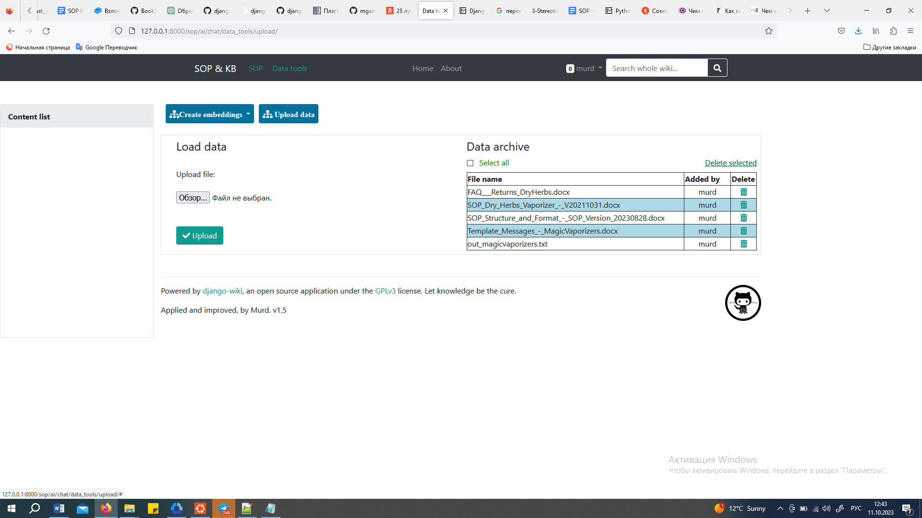

* **"Embeddings" -** forming a marked database for AI. Separately for chat and separately for texts. The table on the right shows which data has already been used in the database and which has not. The database can be created anew with the selected data set or any of the downloaded files can be added to the database already created for AI.

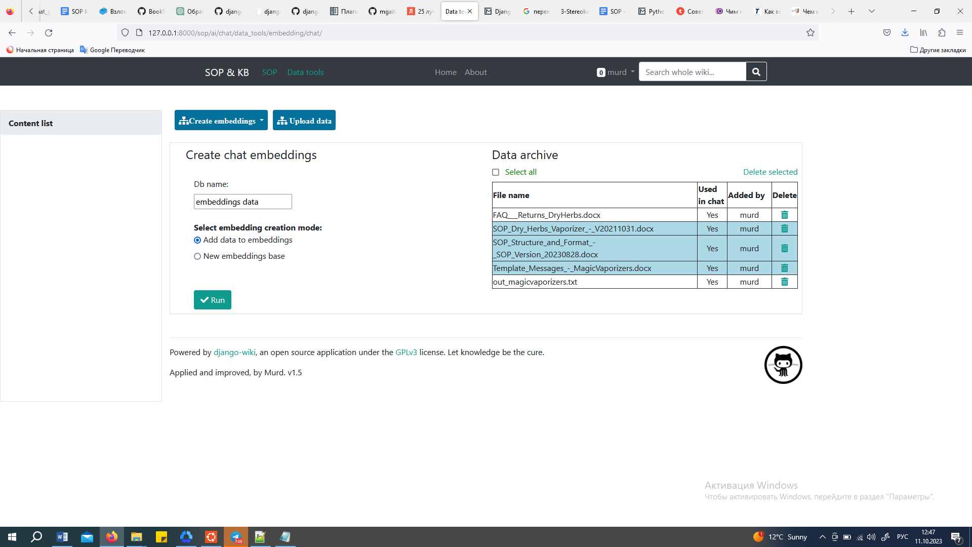

**- “Use assistant”**

Using the assistant, you can generate new articles using only the site database and chatGPT, or based on user content and the site database and chatGPT.

Also, with the help of the assistant, you can automatically edit already created content, headings or summary of articles.

To create an article using AI, you must first create an article template (create an article by specifying only the title without content).

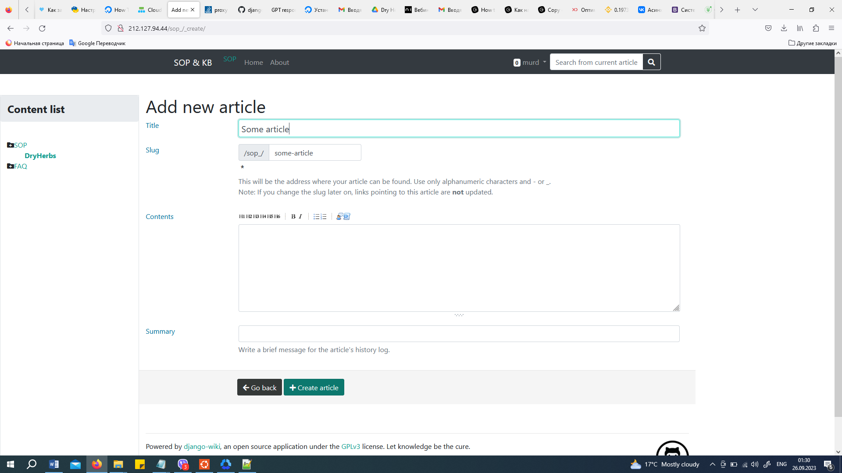

We enter editing mode.

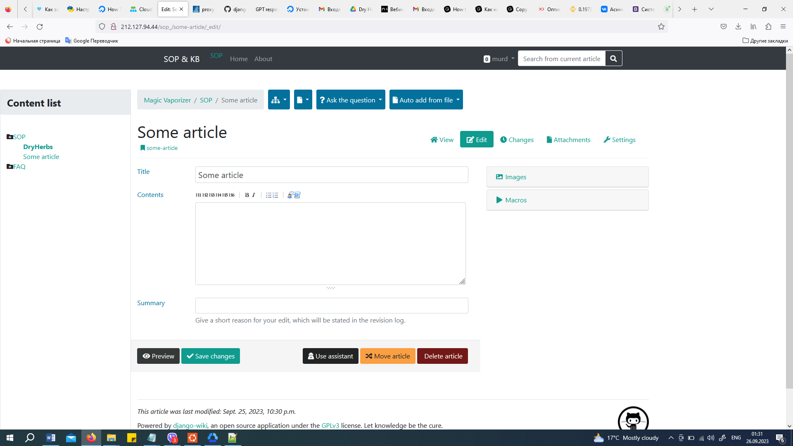

Then click the “Use Assistant” button and, in the window that appears, indicate to the assistant the parameters of the article being created.

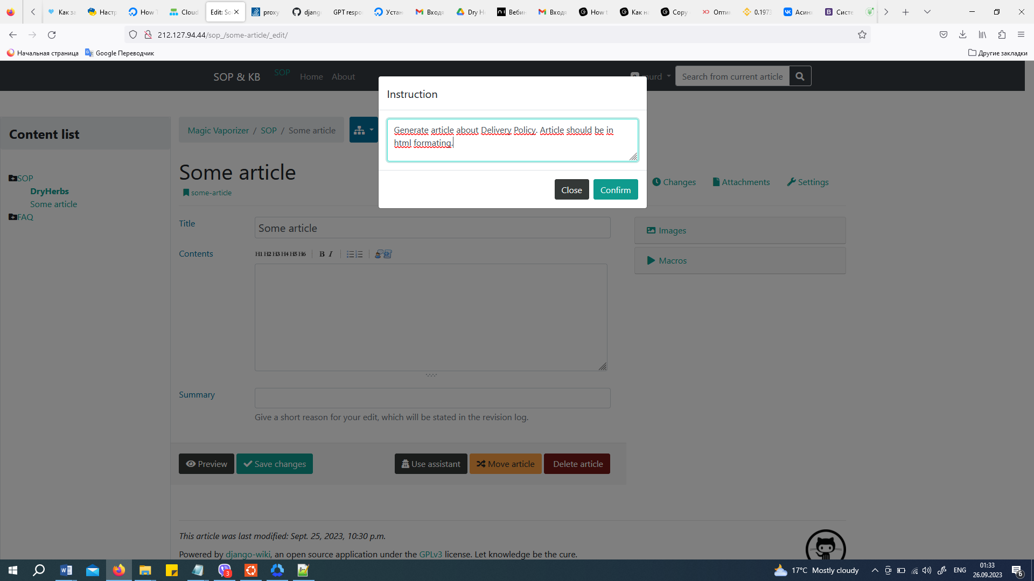

The result will be shown in the article editor window.

A new title can be generated automatically.

If the assistant does not have enough data or does not understand the criteria for creating an article, he will write about this in his response to the request.

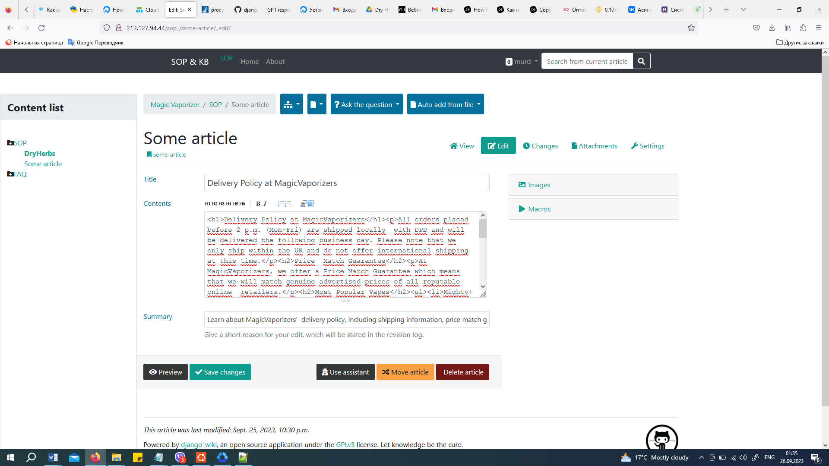

By clicking on the "Preview" button, you can see the result of creating, editing and formatting the article.

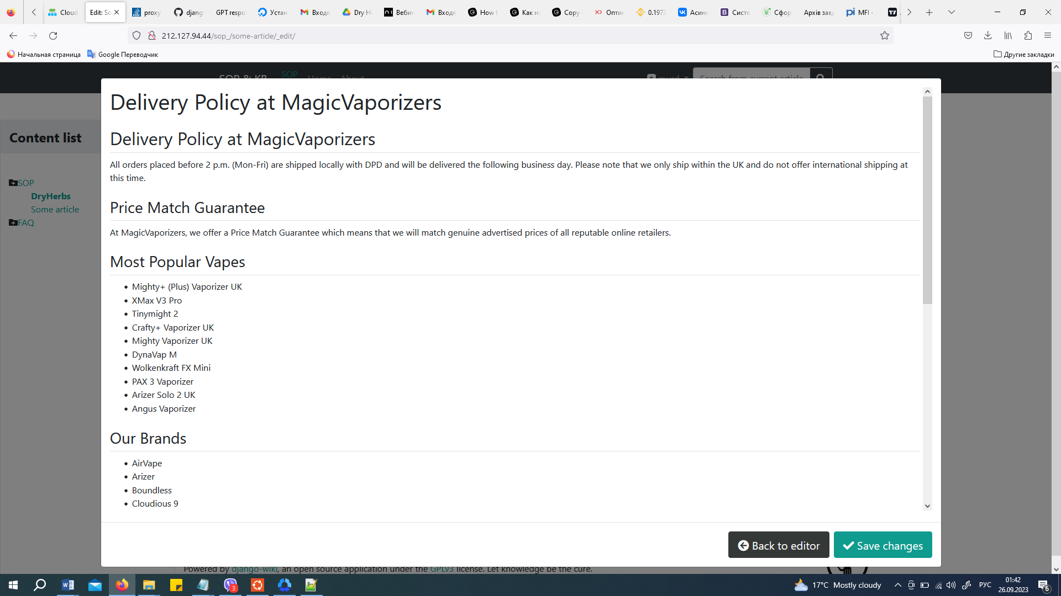

If you need to use any additional data or unprocessed text, you need to paste it into the content field and save the article. Then use an assistant, giving him the necessary instructions.

To edit an article (for example, present content in HTML-formatted form or generate a new title) - select the article, enter editing mode and use the assistant.

To save the result or changes made, you must click the "Save changes" button.

All subsequent assistant actions will be applied only to the saved article data.

**- Drafting the SOP**

"Based on the raw data from the SOP document, draft a structured Standard Operating Procedure (SOP) for handling customer inquiries." (The "Add SOP"B button is activated only in the SOP section)

Select the SOP menu item:

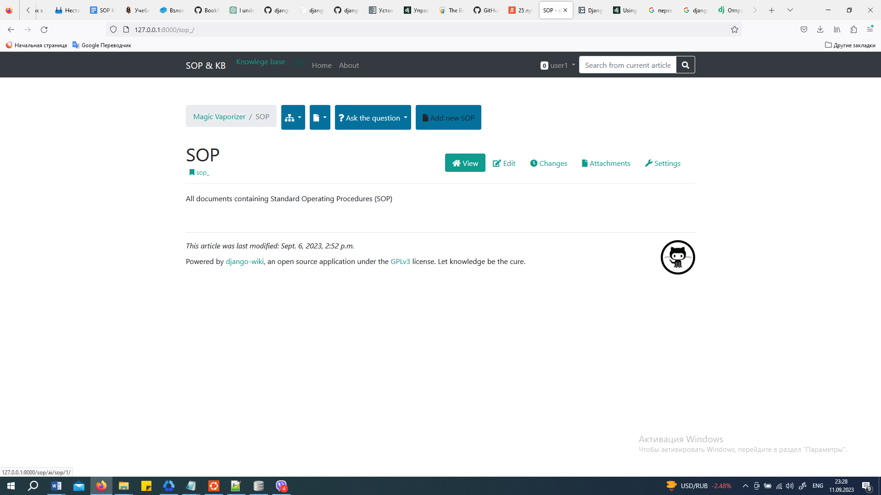

Create SOP document from file. For now, only files uploaded to the server from Google Drive. It will be possible to add a file selection from the user's device.:

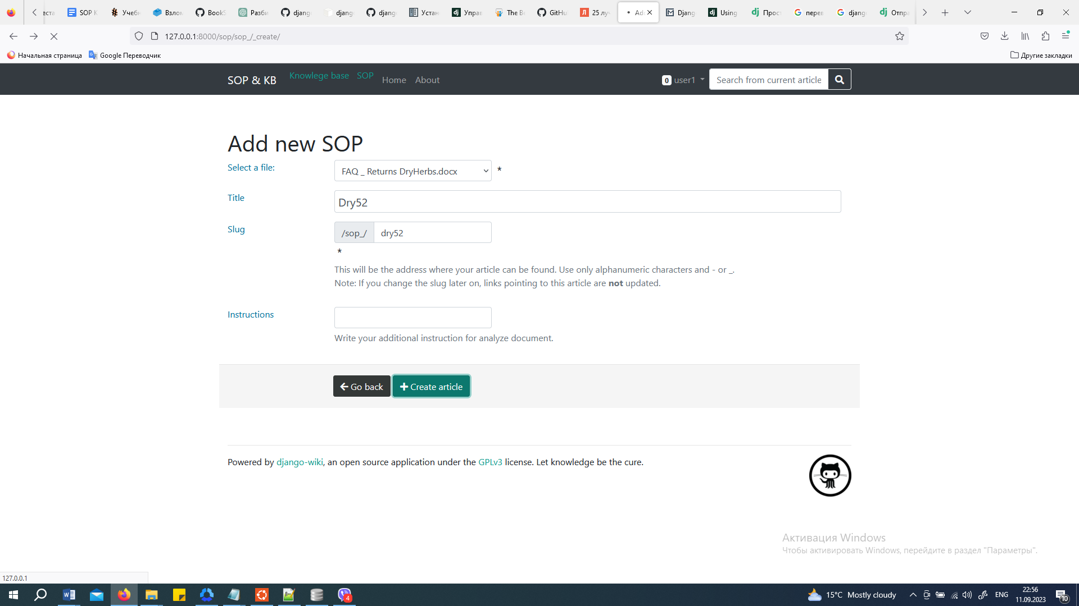

After this …

